The dangers of NGO-isolation of women's rights in Africa

*NGOs agendas in Africa depoliticize women's rights and sideline and weaken grassroot African activism.*

[](https://www.aljazeera.com/profile/hala-al-karib.html)by [Hala Al-Karib](https://www.aljazeera.com/profile/hala-al-karib.html)

13 Dec 2018

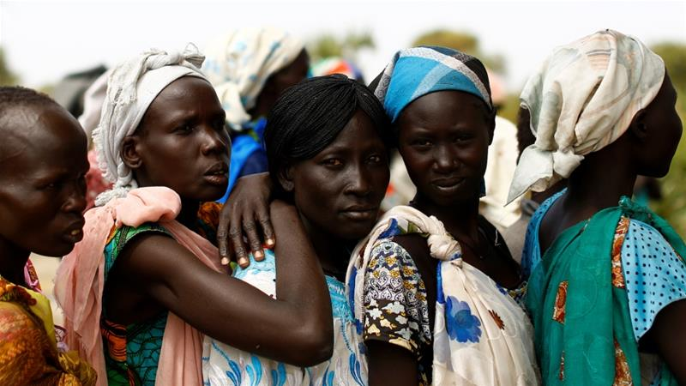

The de-politicization of the women's movement is extremely dangerous for the future of African women.

The emancipation of women is one of the most significant aspects of social and cultural transformation around the world. Women are gradually moving to occupy more space in the public arena. However, in Africa, the history and current dynamics of women's emancipation movements are off the radar and often poorly documented beyond women associated with political parties, liberation movements, or NGOs which receive funding from the global North.

For years, African women have broken through multiple layers of alienation and repression, enduring slavery, colonialism, post-colonial state patriarchy and victimisation, further compounded by cycles of armed and civil conflict that have forced women into roles as combatants, survivors and victims. The engagement of women in reconciliation and inter-communal peace is sidelined and superficially addressed in political processes.

Over the past 40 years, women - particularly poor women who are the majority of the continent's population - have struggled with the impact of privatisation and open-market economies which, in turn, affected women workers, teachers, midwives, healers, farmers, and cattle herders. They all lost their work in some form or another, as well as the opportunities to progress and engage in independent collective feminist movements.

For example, in Sudan and South Sudan, midwifery, nursing and teaching jobs were predominantly filled by women who had strong unions during the 1960s and 1970s. These unions served as incubators for the feminist movement, where working women with access to rights discourse and collective actions took initiative to spread the message of women's liberation and sought to lead by example.

Yet these jobs and the unions that accompanied them have totally collapsed since, with generations of women becoming un/under-employed and forced to surrender to dark social and economic realities.

By the 1980s and 1990s, the collapse of trade unions and privatisation led to, among other things, polarisation and armed conflicts across the region - exacerbating the problems faced by vulnerable women.

Those who were forced to adjust - commonly by migrating to urban centres and across borders in search of alternative work - assumed any form of livelihood available to them, such as vending, domestic work, petty trading and low-paid service jobs.

Subsequently, the women's movement lost its collective power. Women lost their solidarity, their connection to each other and most significantly and sadly, their capacity to engage in politics collectively because they had been uprooted, displaced and polarised.

The civil space in the Horn of Africa is now fully occupied by NGOs. For the past 40 years, we have been living in times of what I regard as "the NGO-isation of civil space", where the language and rhetoric of gender equality is mostly generated by international NGOs.The challenge of NGO-isation is that it is predominantly subject to the imagination, assumptions, and interest of Northern funding institutions and their surrogates.

For example, challenging [female genital mutilation (FGM)](https://www.aljazeera.com/indepth/features/2017/10/female-genital-mutilation-fgm-171004101413764.html) has been a priority issue that dominated the work on women's human rights across the Horn of Africa for over 40 years - meaning that to be an activist for women's rights and gender equality, one is obligated to work on and speak out about FGM - constructing a distorted view of what it means to be a women's rights activist and institution.

This has occurred despite the fact that women in this region have a long history of political and social struggle, which endures to this day. Yet most Northern institutions reduce women's rights and violations against women to a one-dimensional fight against FGM.

Without a doubt, FGM is a violation of women and girls' rights - but it is a symptom of a deeply-rooted culture that seeks to undermine and subordinate women by controlling their bodies, a culture that has been nourished and fed by ultra-conservative political regimes.

**Nobody needs the headache of politics**

Consequently, most women's organizations turned into passive spaces where people don't "do" politics. The work on women's rights has become more focused on PR and the presumed activists became elites competing over resources and privileges.

In this context, the rhetoric of gender mainstreaming becomes a box-ticking exercise while minimizing the root causes of women's subordination and the politics behind that subordination. The few publicly-aware activists become the outsiders, bearers of bad news, and are often labelled as too difficult - too political.

This de-politicization of the women's movement is extremely dangerous for the future of African women. It has already influenced generations of younger women in our part of the world, causing them to aspire to work for NGOs on women's rights to claim social and economic privileges rather than making any meaningful change.

In countries where the majority struggle with accessing basic human needs, the local NGO elites use their positions to gain privilege while making a point of avoiding the pain of politics. But the conversation about women's rights and building the women's agenda cannot be attained without political activism.

#MeToo in Africa

The #MeToo movement has been crucial in exposing settled power relations that relay the subordination of women. However, even in the Northern context, a movement like #MeToo can easily be aborted and manipulated by the powerful patriarchal system if it is not clearly defined and structured against the patterns of power relations that are designed to undermine women and marginalized people. #MeToo could eventually be co-opted under the current global trends of growing conservatism and socioeconomic polarization.

This is why, as African women, we need to refrain from blindly following Northern dynamics and rhetoric when it comes to the women's rights agenda, and think very carefully about our own #MeToo movement. The African #MeToo must be based on and informed by the complex realities of our experiences.

Women have spoken out in Africa since long ago - but in a vacuum. Our judicial institutions are still lagging behind on human rights and justice and they are predominantly patriarchal in nature. Therefore, it is important for women's rights activists to foreground their political understanding while pursuing equality and justice. 

We live in societies where violence is legitimized and deeply integrated into our laws and cultural norms. Polygamy is rampant and most of our countries do not have personal status laws that observe women's rights and humanity. Sexual violence remains a feature of women's lived realities. Of late, waves of Islamic and Christian fundamentalism are spreading and finding a fertile playground to institutionalize misogyny in our societies.

The question is: To what extent are the current modalities of intervention prioritized by Northern governments and surrogates contributing to women's movements in the Horn of Africa and elsewhere in the continent?

The risks of blindly following Northern dynamics and rhetoric

There is no doubt that international support has played, and is playing, a significant role in enabling the continued existence of a women's rights discourse in Africa. Nevertheless, Northern support has largely controlled the women's rights and gender equality agenda along with our imagination, ultimately reducing our capacity as activists to own the conversation.

More significantly, the providers of international support have been allowed to decide what constitutes activism's successes and failures, and who can be recognized as legitimate activists.

Thus, many groups without a drop of activist spirit in their blood, whose stance completely contradicts the ideological needs and the essence of feminism and women's rights, are promoted haphazardly because they comply with the regimented terms of engagement (the rules of the game).

On the other hand, activists who struggle to own the agenda have to stay under the radar and are often stigmatized as being "too political".

Moreover, most of the current modalities of Northern support to the South are heavily merchandised. Work on social change and gender equality is gradually being turned into a commodity under the claim of addressing corruption and taking control of resources and spending. In the past 20 years, USAID and the UK government have channeled the majority of their resources to developing countries through private companies.

These types of sub-contracting companies who act solely based on financial calculations were put in control to engage on extremely complex issues, including peace and reconciliation, sexual violence, anti-terror and others. These entities lack not only expertise and knowledge but also the genuine interest and empathy that would qualify them for a role within local civil society.

Today, the engagements between the North and South on women's rights are not based on solidarity as they are supposed to be. Instead, the rhetoric of gender equality and women's rights is being used by northern institutions to capitalize on these ideas. Conservatism which is now dominant in many of these institutions is encouraging the de-politicization of women's movements, as it has no real interest in a growing African women's movement and social transformation.

This cannot lead to the change we need. We cannot talk about change and movement-building under these terms of engagement. Unless fundamental and brave reforms occur, human rights, women's rights and social development will be overtaken by merchandise institutions.

Women's movements are political movements. They are about power relations, political positions and goals, engaging in politics beyond mere representation, rather as conscious constituencies that have clear aims and tools for resistance and are dedicated to values of solidarity.

Women activists and feminists around the world should always remember that our engagement in women's rights is based on what we have suffered and continue to suffer. As African feminists and activists for women's rights and equality, let us never forget that the burden is ours to carry, and to own.